**Unit 3 Triangle Congruence Quiz 1**

*21 points*

Use the diagram to the right. Give the reason as to why each statement is true. *(2 points each)*

1. 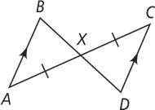∠*BAX* ≅ ∠*XCD*
2. ∠*AXB* ≅ ∠*CXD*
3. ∆*ABX* ≅ ∆*XDC*

4. Write a two-column proof for the following: *(4 points)*

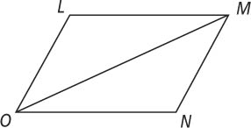 Given:

∠*LMO* ≅ ∠*NOM*

*LM* ≅ *NO*

Prove:

∆*LMO* ≅ ∆*NOM*

5. Write a two-column proof for the following: *(5 points)*

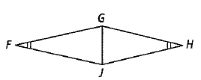 Given:

*FG* || *JH*

∠*GFJ* ≅ ∠*GHJ*

Prove:

∆*GFJ* ≅ ∆*JHG*

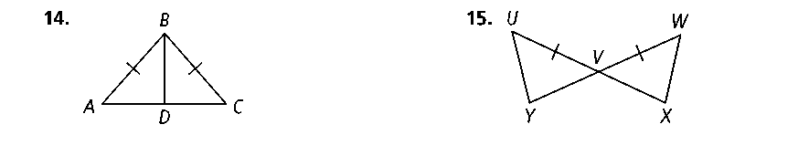6. Write a two-column proof for the following: *(6 points)*

Given:

*AB* ≅ *BC*

*BD $⊥$ AC*

Prove:

∆*ABD* ≅ ∆*CBD*